Chapter 5, Problem 88

Figure 5.106 shows an instrumentation amplifier driven by a bridge. Obtain the gain v_{o}/v_{i} of the amplifier.

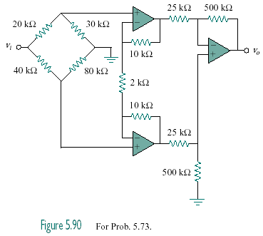
Figure 5.106
For Prob. 5.88.

